Project 5-1: Provide screen shot for step 8

Project 5-2: Provide screen shot for step 9c

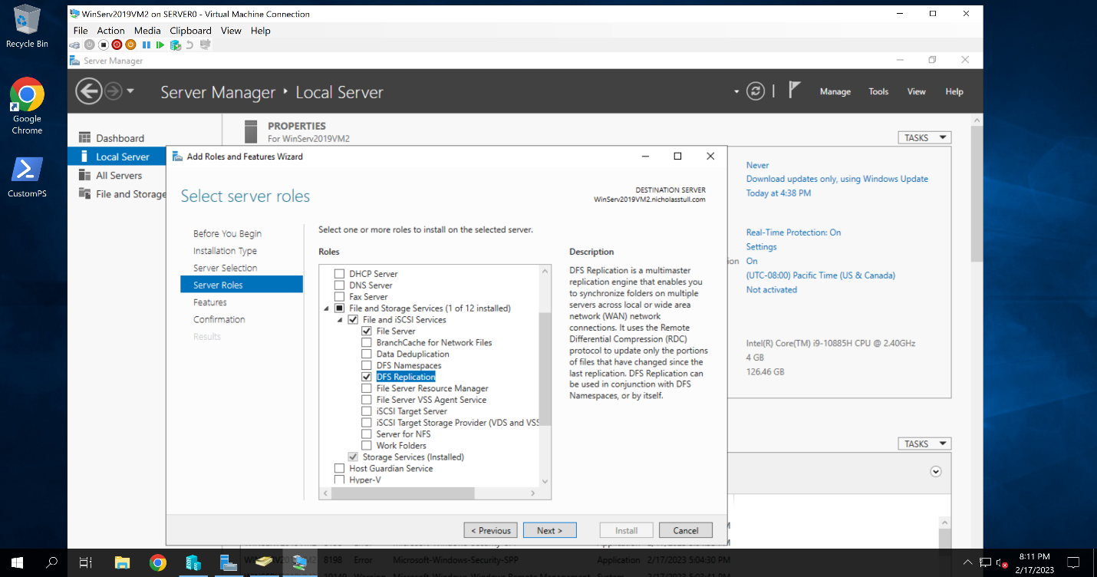

Project 5-3: Provide screen shot for step 8

Project 5-4: Provide screen shot for step 9

Project 5-5: Provide screen shot for step 11h

b.burtt (Newpassw0rd)

Project 5-6: Provide screen shot for step 15g

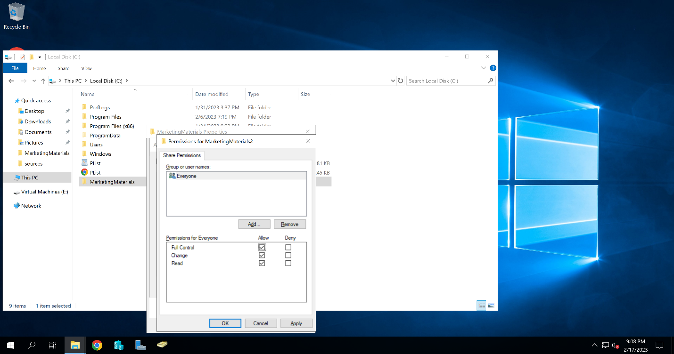

Project 5-7: Provide screen shot for step 8d

Project 5-8: Provide screen shot for step 3k

Make sure to use your secondary drive and not your C;\ for this activity

